Login information SEAS in Hystore Pilot Montserrat

Connection to the SEAS edge server
You can login to SEAS edge server via the credentials below via Teamviewer app.

Hystore SEAS
##Maston2025 password via TeamViewer
admin: rock
passw: rock

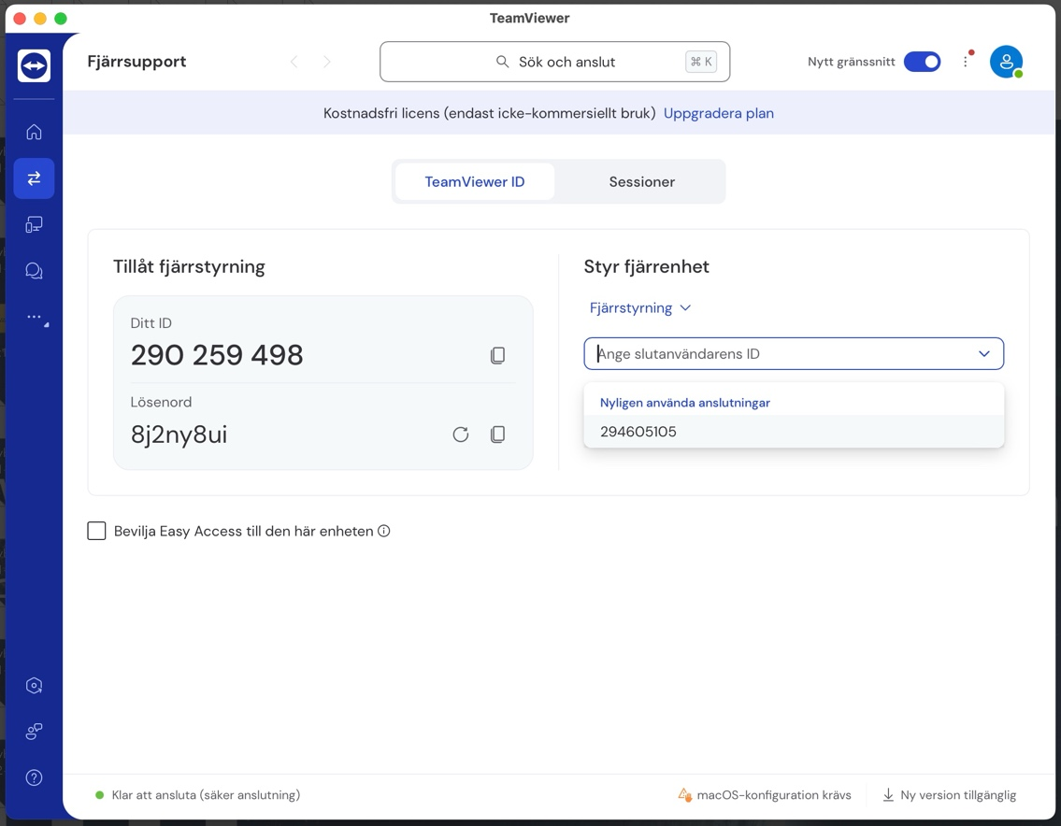

The main SEAS deskop window should appear as in the image below. You can install applications and run them (preferably in Docker for paraling tasks).

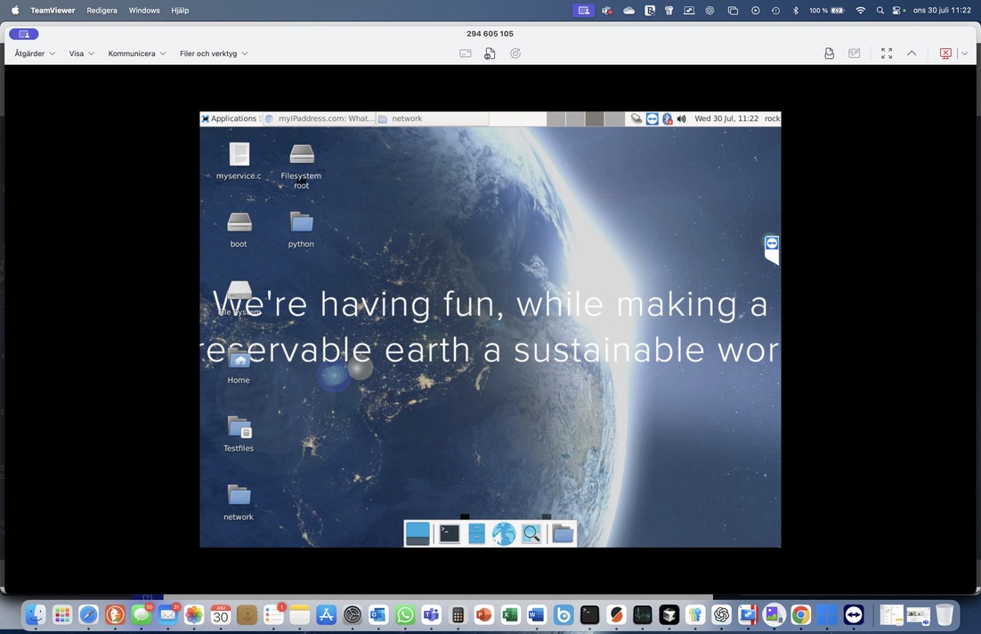

Connection to Montserrat local BMS

The connection to the local BMS may be established to reach data but only for viewing data, no changes possible.

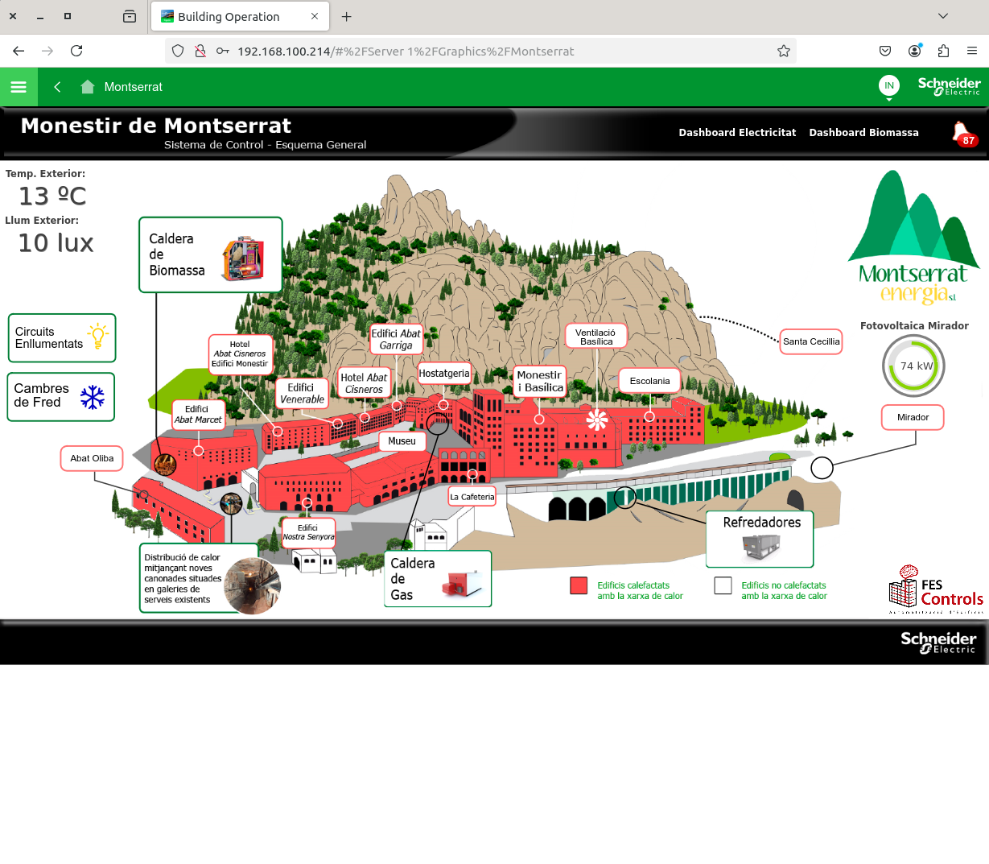

Alternate connection to connect also on Linux OS using the netExtender client

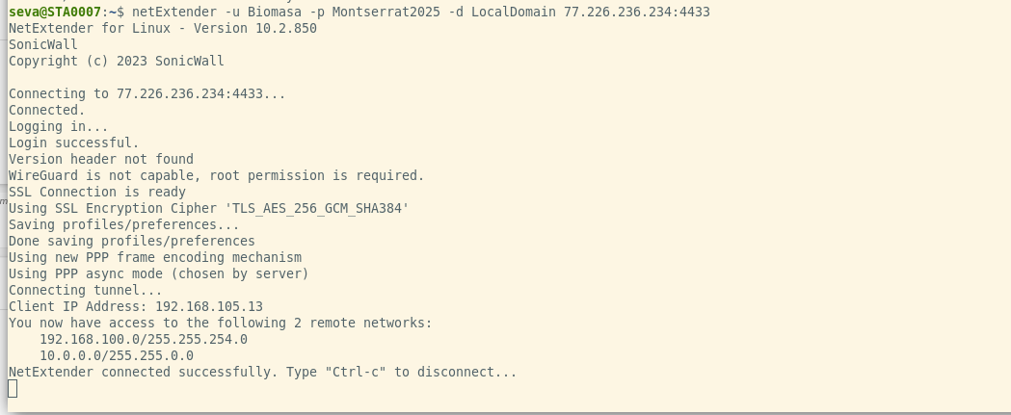

To access we use windows. First installing ‘Sonicwall mobile connect’ from the microsoft store.
Then we create a new VPN with the client ‘Sonicwall mobile connect’ with any name, in this case we use Montserrat.

In the server section we use the following ‘https://77.226.236.234:4433’.
With this configuration we don't need a domain.

The username and password for the VPN is:

User: Biomasa
Password: Montserrat2025 (or montserrat2025)

Then to test the connection you can use the remote desktop with the above mentioned configuration:
- Remote Desktop (due to a recent update schneider BMS has problems with chrome and edge browsers, use another one i.e. Firefox):
  - Address: 192.168.100.214
  - Username: informatica
  - Password: Montserrat2025 (or montserrat2025)
  - Domain: Montserrat

To run software with the embedded Melacs communication boards inside the SEAS edge server

The code is installed on sub-boards that handle all I/O communication to the hardware ports in the unit. Right now there are no hardware sensors connected yet. The IoT datatable is possible to reach via MQTT subroutines. At the moment we have the code but are still building the Github Wiki page with instructions.

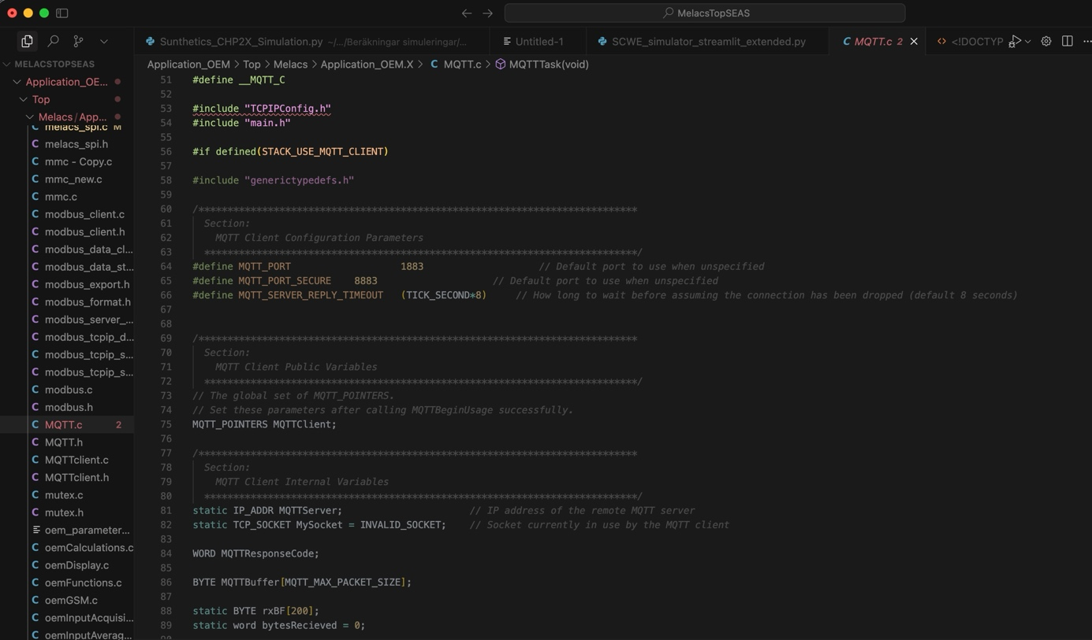

All communication is via Modbus ethernet already connected to the dedicated SEAS and PLC router on the site. When the heat storage systems are installed that data will be possible to reach via the SEAS server and its backup disks and database.

The onthology is developed by Hystore in separate tasks (se those reports separately).

